Judge's House map praised Engel, Lowey, Hayworth shift territory
by Jon Campbell and Brian Tumulty

March 7, 2012

ALBANY — A federal magistrate judge released her proposal Tuesday for consolidating New York’s congressional districts from 29 to 27, altering the districts now held by Reps. Nan Hayworth, Eliot Engel and Nita Lowey. The plan closely follows the geographically compact lines suggested by Common Cause and other good-government groups.
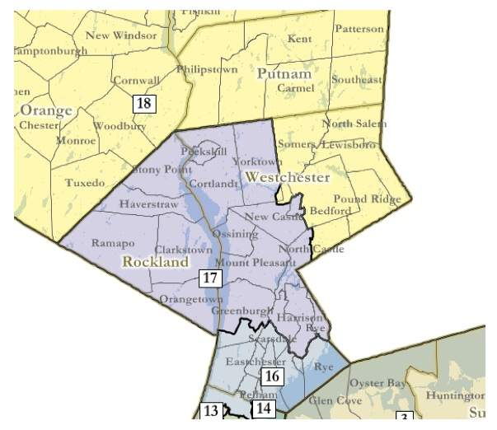
The federal magistrate proposes these congressional districts covering Westchester, Rockland and Putnam counties
Susan Lerner, executive director of Common Cause New York, called it a “vast improvement” over boundaries proposed by the Assembly and state Senate because it “keeps regions whole and unites communities of interest.”

Several members of Congress who would be affected by the proposed lines declined comment Tuesday, including Republican Reps. Hayworth of Bedford, Tom Reed of Corning and Chris Gibson of Kinderhook.

“It’s not something I can personally influence,” said Gibson, who is in his first term. “I’m focused on my responsibilities.”

However, Rep. Louise Slaughter, D-Fairport, expressed dissatisfaction with the proposed Rochester-based district.

“We are not happy with it,” Slaughter said. “They cut the district up pretty much from what we asked for. We were looking for Democratic performance. Frankly, I would have liked to go down to Ithaca.”

Slaughter said she hopes the state Legislature can reach a deal, saying the magistrate’s plan doesn’t give enough consideration to protecting incumbents.

If the Democratic-led Assembly and Republican-led state Senate can’t agree on new lines, they would be forced to accept the magistrate’s map. The decision on the new districts will rest with a three-judge federal court in Brooklyn because New York’s redistricting requires a judicial review for compliance with the Voting Rights Act’s protection of minority voters.

New York loses two House of Representatives districts next year because the state’s population grew slower over the past decade than that of other states, such as Texas, which is adding four districts, and Florida, which is gaining two.

U.S. Magistrate Judge Roanne Mann’s proposal for New York follows the Assembly and state Senate in proposing to carve up the Southern Tier and mid-Hudson Valley seat of Rep. Maurice Hinchey, a Democrat from Ulster County who is retiring at the end of the year.

A second congressional district would be eliminated in Queens. Freshman Republican Rep. Bob Turner would be placed in the same southern and central Queens district as veteran Democratic Rep. Gregory Meeks.

The Assembly had proposed a contest between Turner and another incumbent Queens Democrat, Rep. Joe Crowley. The Senate had proposed pairing two incumbent Democrats in Nassau County, Reps. Gary Ackerman and Carolyn McCarthy.

In the Lower Hudson Valley, veteran Harrison Democrat Lowey would lose much of her southern Westchester County political base and pick up all of Rockland County and the northwest corner of Westchester.

Engel of the Bronx, another veteran Democrat, would lose his foothold in Rockland and would have to run for re-election in much of southern Westchester, including New Rochelle, Rye, Eastchester and Scarsdale. The district also would include Yonkers and Mount Vernon.

Farther north in the Hudson Valley, two other districts would straddle the Hudson River.

Freshman Hayworth lives in a district that would look much like her current one and would cover northeastern Westchester, southern Dutchess County and Putnam and Orange counties.

Gibson lives in a proposed upper Hudson Valley-Catskills district that would be more compact than his current one, which stretches as far north as the Lake Placid area. The four northernmost counties of Gibson’s district would become part of a North Country district.

The new upper Hudson Valley-Catskills district would stretch as far south as the Putnam County border in eastern Dutchess County. It also would pick up Ulster County, Sullivan County and parts of Delaware and Broome counties from Hinchey’s district. Other new areas would come from districts now represented by Republican Rep. Richard Hanna and Democratic Rep. Paul Tonko.

The magistrate’s map also would create a rural western New York district where no incumbent lives.

Freshman Democratic Rep. Kathy Hochul of Erie County lives in the same proposed Buffalo-based district as veteran Democratic Rep. Brian Higgins. Hochul formerly lived in Hamburg, which is part of the proposed rural western district. She now lives in nearby Amherst in the proposed Buffalo-based district that stretches north to Niagara Falls and North Tonawanda.

Besides Buffalo, Rochester, Syracuse and Albany would be centers of proposed upstate districts. The new lines would adjust the districts that now encompass Syracuse and Albany. For Rochester, they would represent a major change. The Rochester metropolitan area is now part of four districts.

Slaughter lives in the proposed new district, which would contain most of Monroe County, including Rochester. The Monroe County towns of Hamlin, Wheatland, Mendon and Rush would be placed in the proposed western New York district where no incumbent resides.

The magistrate’s map also would place Reed in a reconfigured Southern Tier district that would include Tompkins County and the heavily Democratic city of Ithaca. The western end of the district would extend to Lake Erie. Both the Senate and Assembly had proposed including Tompkins in the district represented by Syracuse-area Rep. Ann Marie Buerkle, a conservative Republican.

Hanna of Oneida County would live in a reconfigured Mohawk Valley-Binghamton-area district that would include most of Broome County and a small part of Tioga County. The more compact district would cover all or part of eight counties instead of the current 11.

Mann’s map was released a week ahead of schedule, one day after she held a hearing in Brooklyn on whether her map should take into account where incumbents live. She will hold another public hearing on all the proposed maps March 15 in federal court in Brooklyn, and there will be three days to make a final decision. The petitioning period for potential congressional candidates to get on a primary ballot begins March 20.

